Safety Cage SPECIFICATION

Biesheuvel Autosport is a 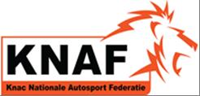certified company for installations off roll-bars
This roll bar is built in under Annexe J artikel 253 self construction

Safety Cage Manufacturer | Biesheuvel Autosport
Address | Rijksweg 37
 | 4255 GE Nieuwendijk
 | Netherlands
Phone n° + Email | 0031 183 403400  info@biesheuvel.nl

The structure shown on this form is manufactured for the following vehicle:
Make | NISSAN | Model | PATHFINDER | Year/Model Identifier | 2008
Vehicle Homologation Number(s)*  *if applicable |  |  | N/A

Drawing of front ¾ view of the Complete Structure showing the location of the identification plate
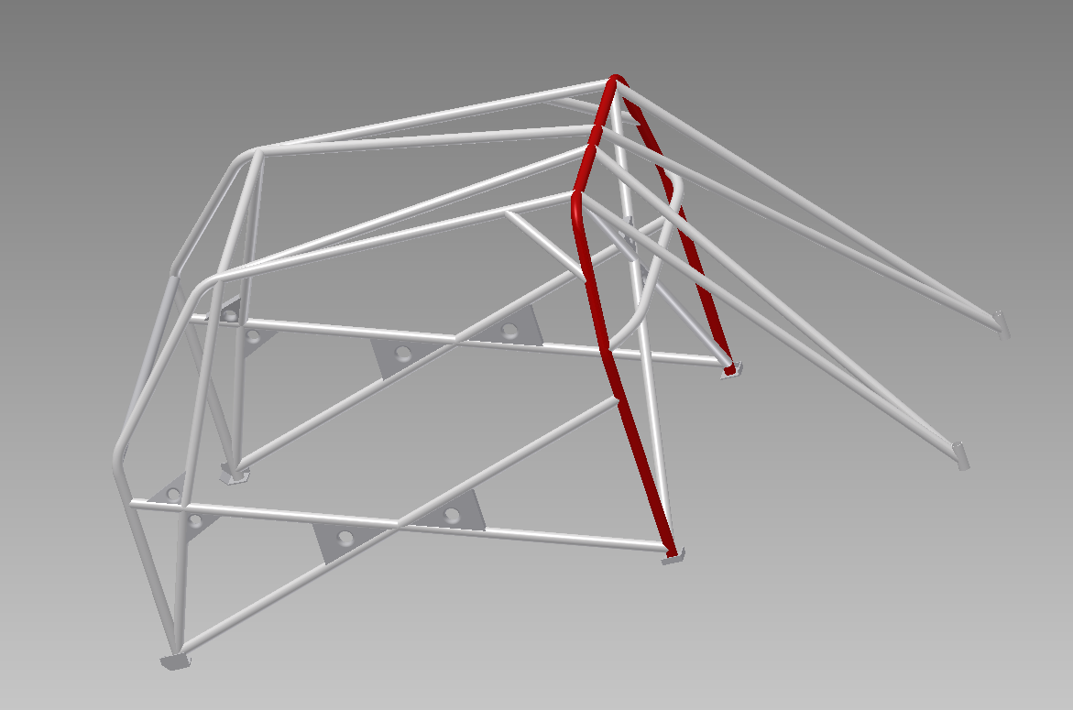
6090

DETAILS OF STRUCTURE
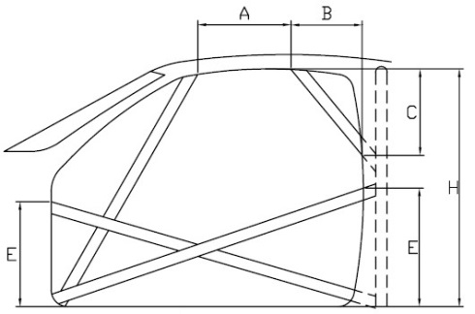 | A = | 380 | mm | B= |  | mm
 | C = |  | mm | E = | 330 | mm
 | H = | 1140 | mm | (E is highest figure only)
All Dimensions ± 5mm

Method of attachment to Body Shell | Welded
Weight of Safety Cage, inc. fastenings | 25 | kg

LABELLED DRAWING OF THE SAFETY CAGE STRUCTURE SHOWING ALL TUBING DIMENSIONS
O
D
S
O1
D1
C
C1
L/F
M
E
B

All Dimensions + 0.1mm |  | Show location of each type on drawing
Tube / Member | Label | Grade of Steel | External Diameter (OD) |  | Wall  Thickness |  | Min. Tensile  Strength
Main Rollbar | M | E235EN/10305-1 | 45.0 | mm | 2.5 | Mm | 480 | N/mm²
Front/Lateral  Rollbar | L/F | E235EN/10305-1 | 40.0 | mm | 2.5 | Mm | 480 | N/mm²
Backstays | B | E235EN/10305-1 | 40,0 | mm | 2.5 | Mm | 480 | N/mm²
Main rollbar  Diagonal members | D | E235EN/10305-1 | 40.0 | mm | 2.0 | Mm | 480 | N/mm²
Backstay  Diagonal members | D1 | E235EN/10305-1 | 40.0 | mm | 2.0 | Mm | 480 | N/mm²
Roof  Reinforcements | C | E235EN/10305 | 40.0 | mm | 2.0 | Mm | 480 | N/mm²
Doorbars | E | E235EN/10305-1 | 40.0 | mm | 2.0 | Mm | 480 | N/mm²
Windscreen Pillar  Reinforcements | C1 | E235EN/10305-1 | 40.0 | mm | 2.0 | Mm | 480 | N/mm²
Harness Bar | S | E235EN/10305-1 | 40.0 | mm | 2.0 | Mm | 480 | N/mm²
OPTINAL TUBES | O | E235EN/10305-1 | 40.0 | mm | 2.0 | Mm | 480 | N/mm²
OPTINAL TUBES | O1 | DIN2391  25CRM04 | 30.0 | mm | 2.5 | Mm | 700 | N/mm²
OPTINALTUBES |  |  |  | mm |  | Mm |  | N/mm²
 |  |  |  | mm |  | Mm |  | N/mm²
 |  |  |  | mm |  | mm |  | N/mm²
 |  |  |  | mm |  | mm |  | N/mm²

Total length of all tubes < 40 mm OD |  | mm | 15 m maximum

Photo 1  FRONT ¾ VIEW OF CAGE |  | Photo 2  REAR ¾ VIEW OF CAGE
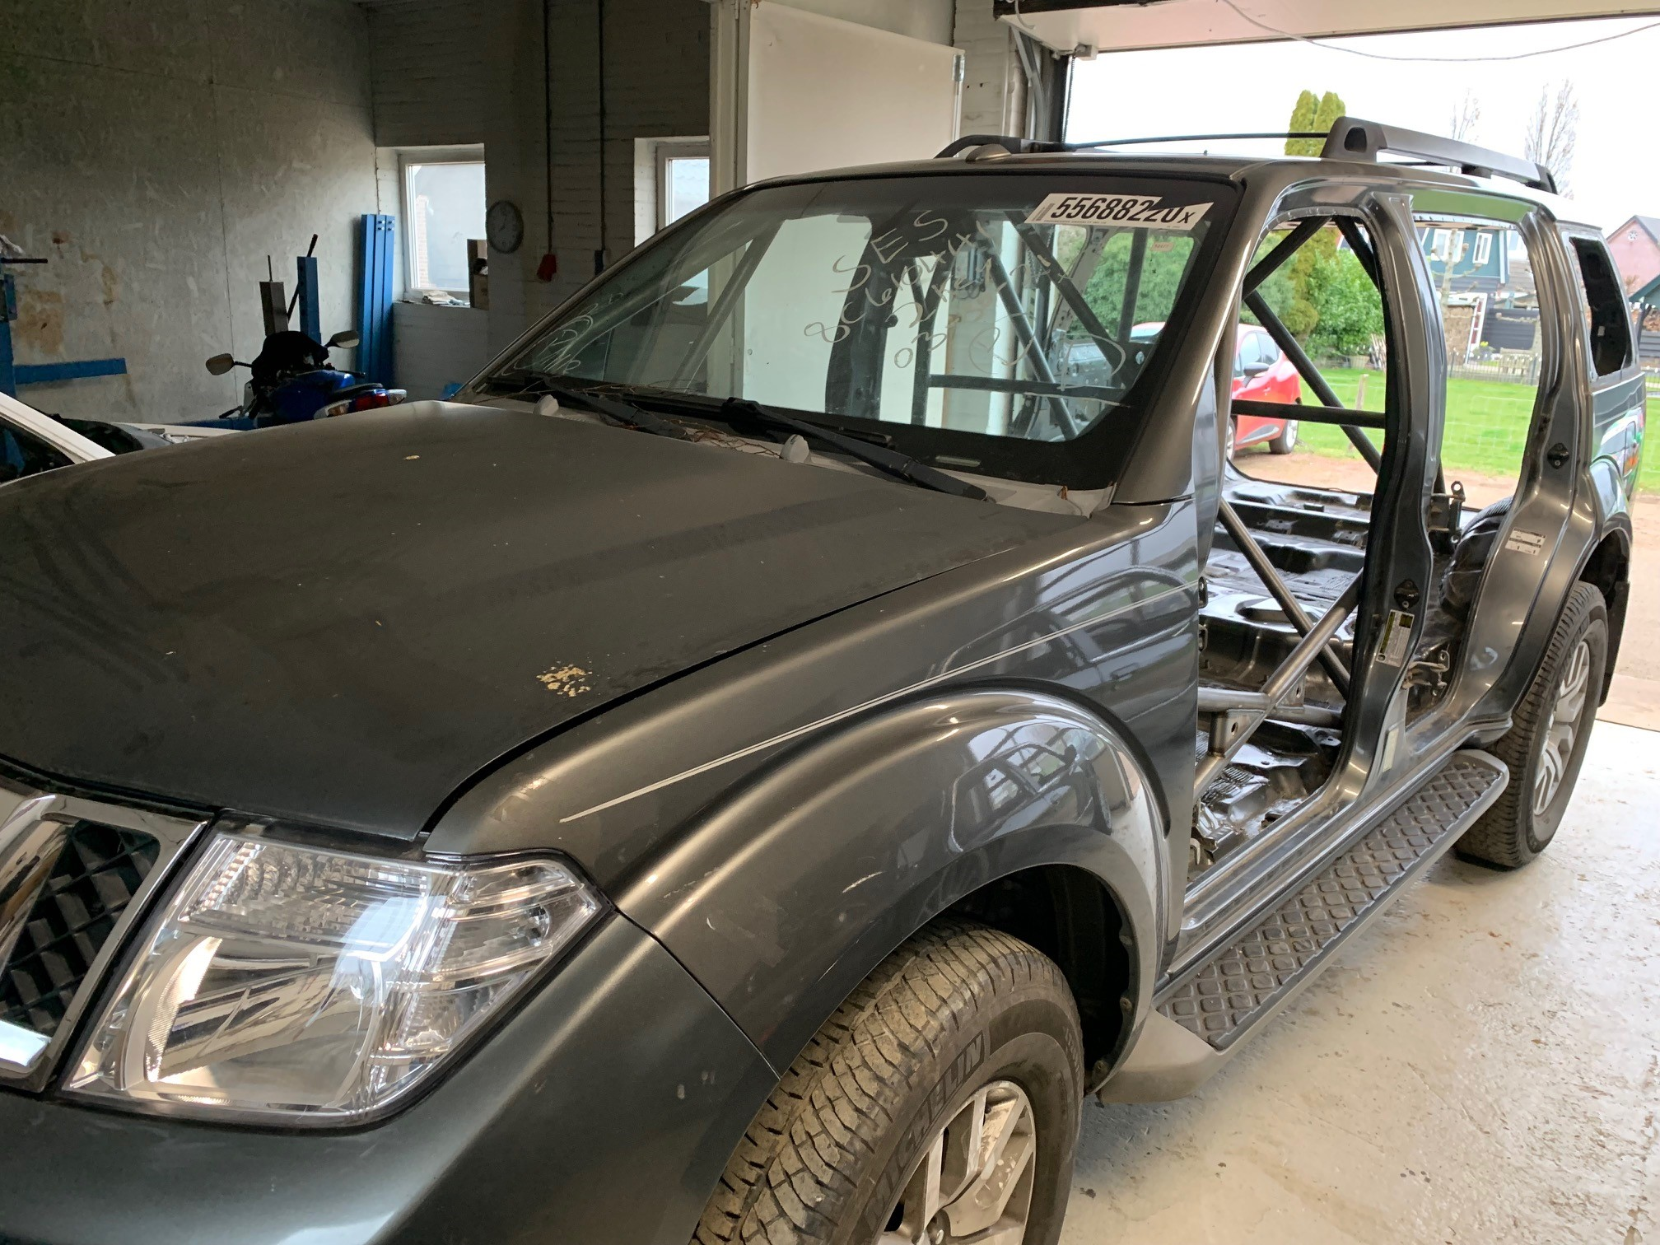 |  | 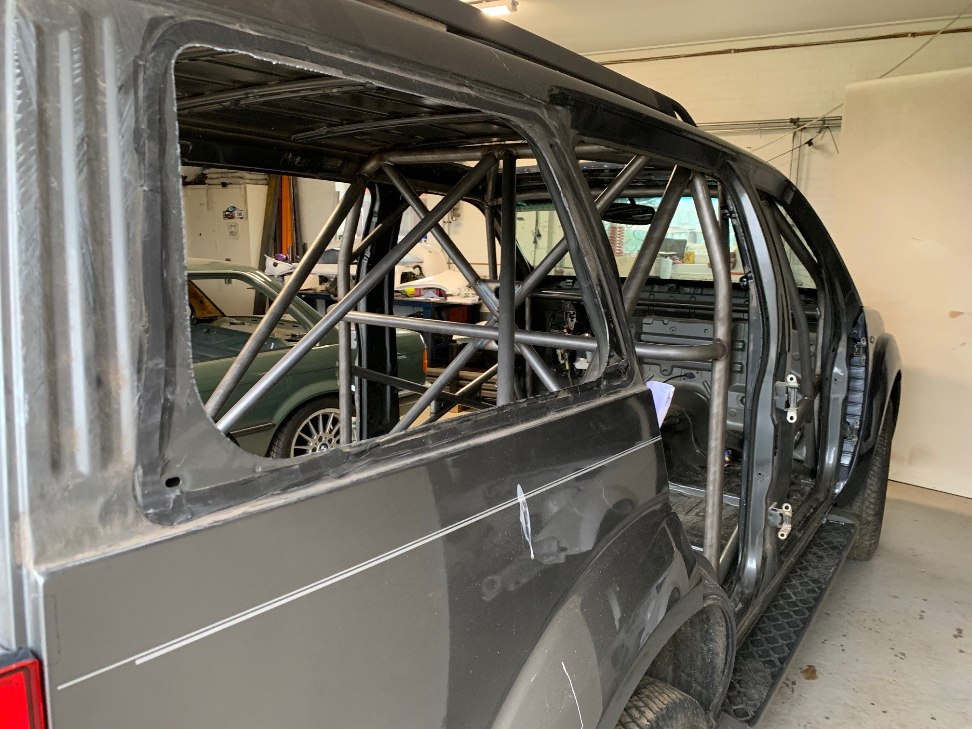

Photo 3  VIEW FROM SIDE OF CAR |  | Photo 4  MAIN ROLLBAR TO FLOOR ATTACHMENT
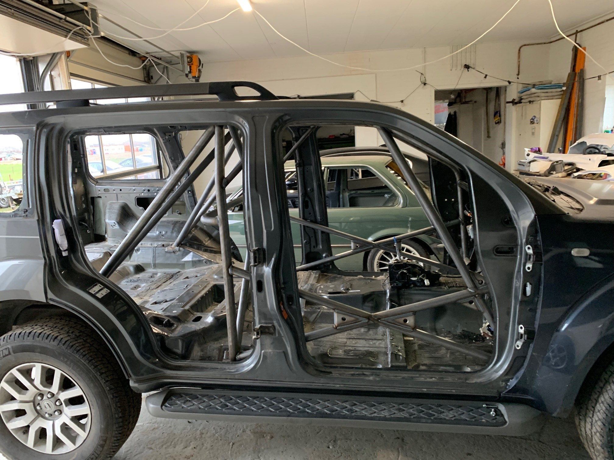 |  | 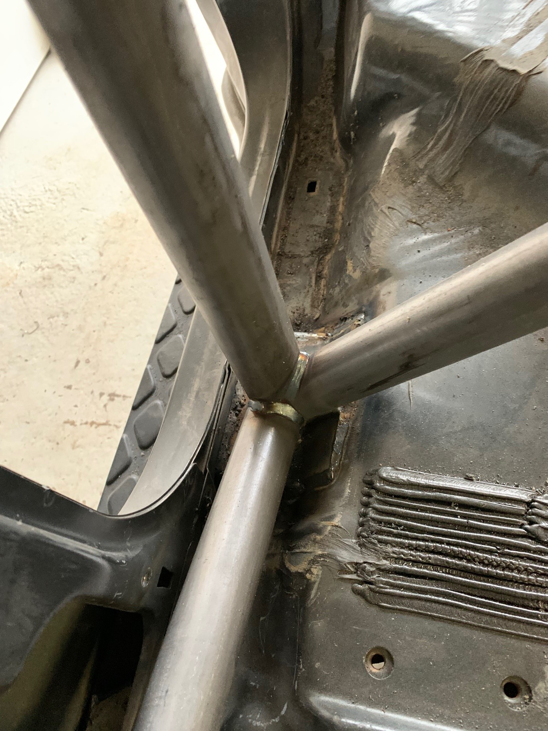

Photo 5  REAR BACKSTAY TO BODYSHELL ATTACHMENT |  | Photo 6  FRONT ROLLBAR TO FLOOR ATTACHMENT
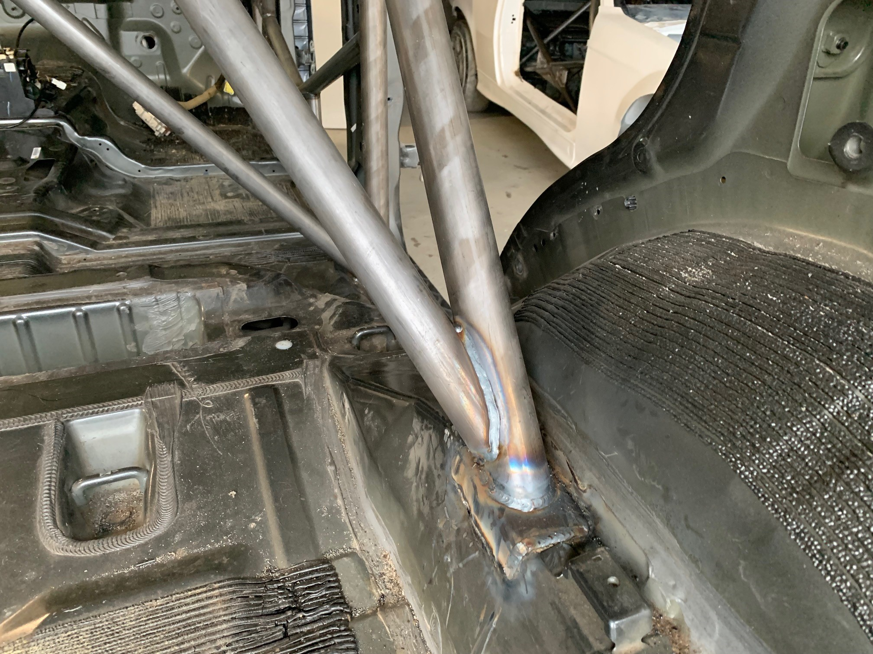 |  | 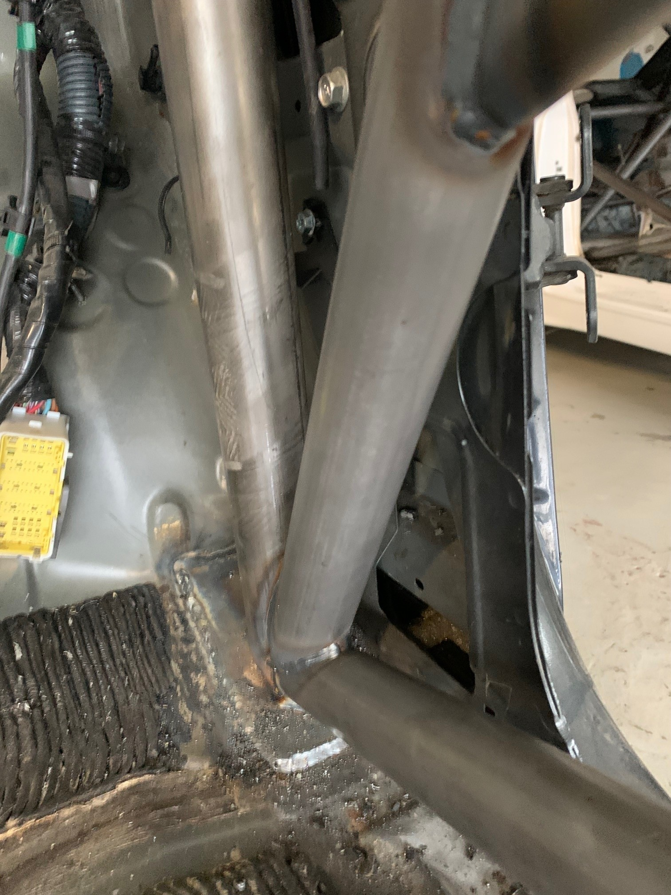

Photo 7  FRONT ROLLBAR TO “a” PILLAR ATTACHMENT |  | Photo 8  MAIN ROLLBAR TO “B” PILLAR ATTACHMENT

Photo 9  ATTACHMENT TO FRONT SUSPENSION |  | PHOTO  Chassis Identification Number

Photo 10  Anti-Intrusion DOORBar - DRIVER |  | Photo 11  Anti-Intrusion DOORBar – CO-DRIVER
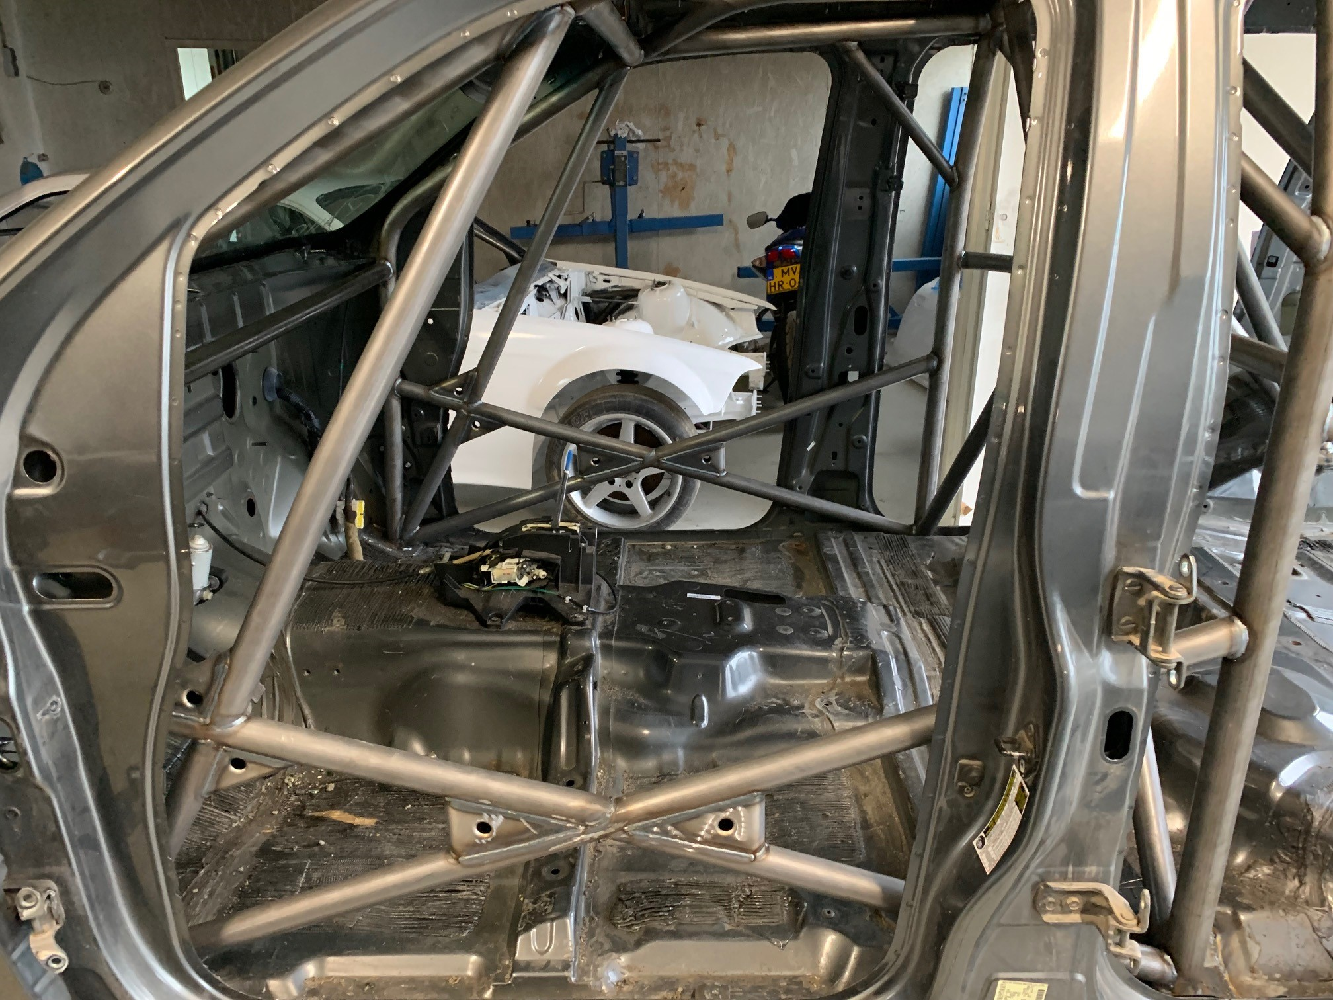 |  | 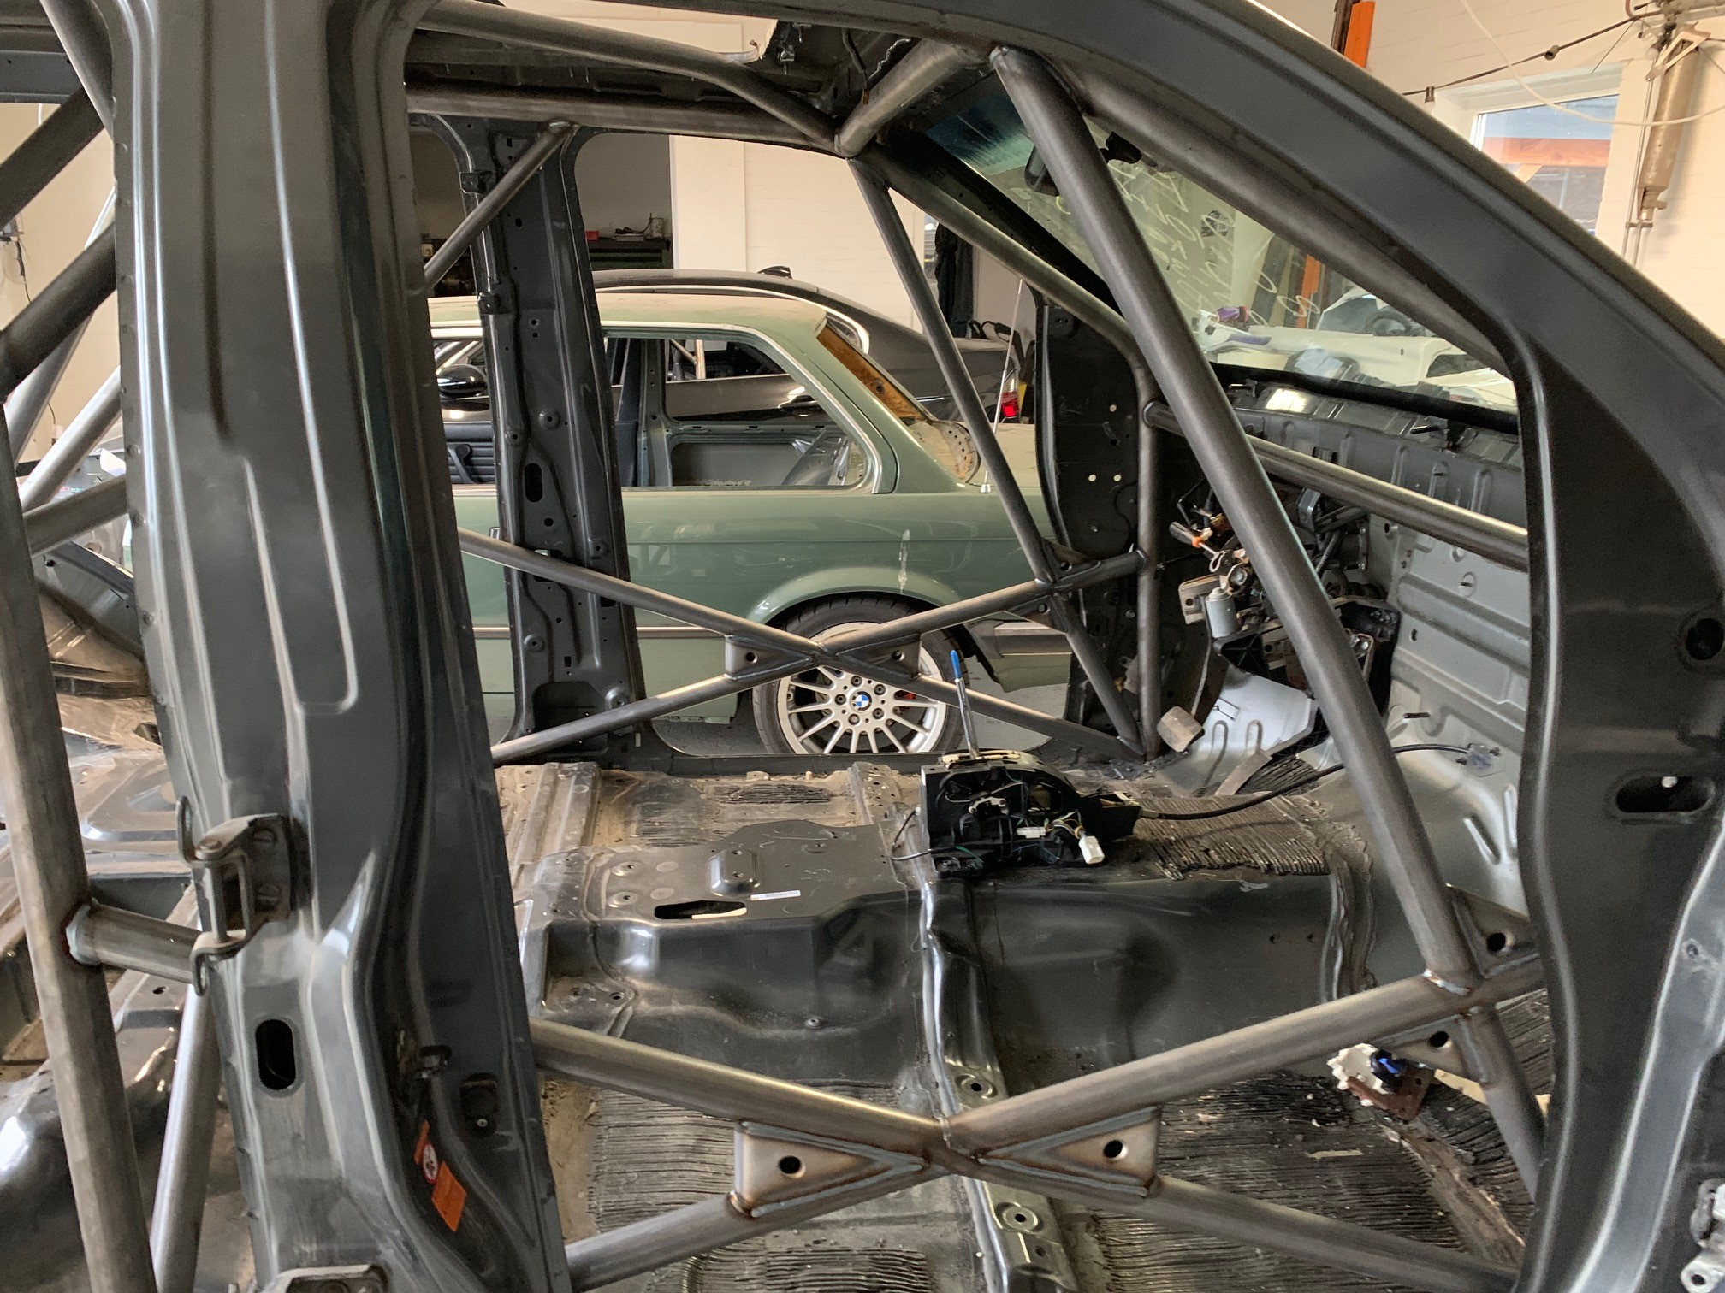

Photo 12  SHOULDER HARNESS ATTACHMENT - DRIVER |  | Photo 13  SHOULDER HARNESS ATTACHMENT – CO DRIVER
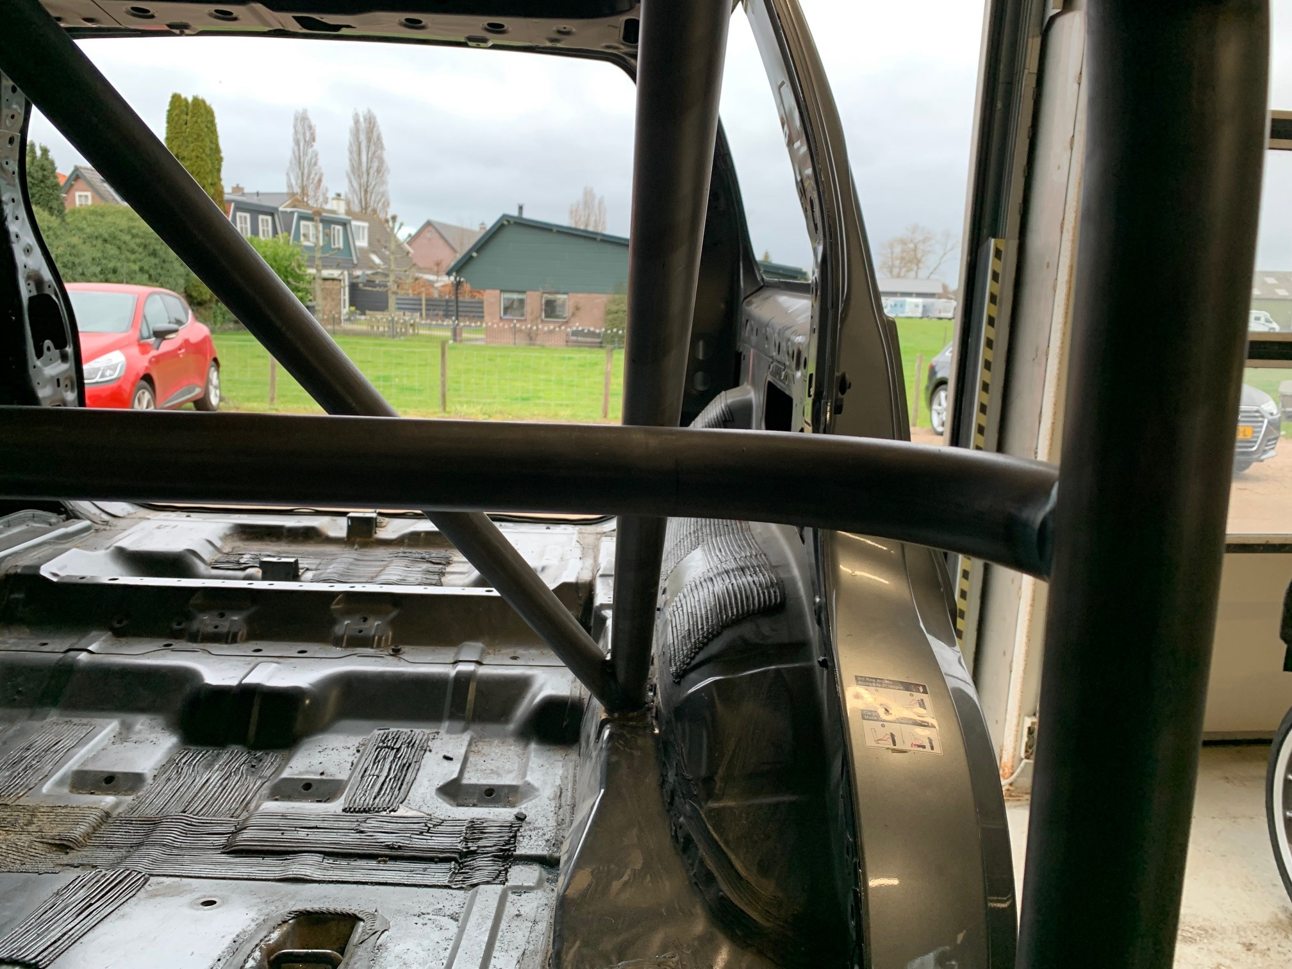 |  | 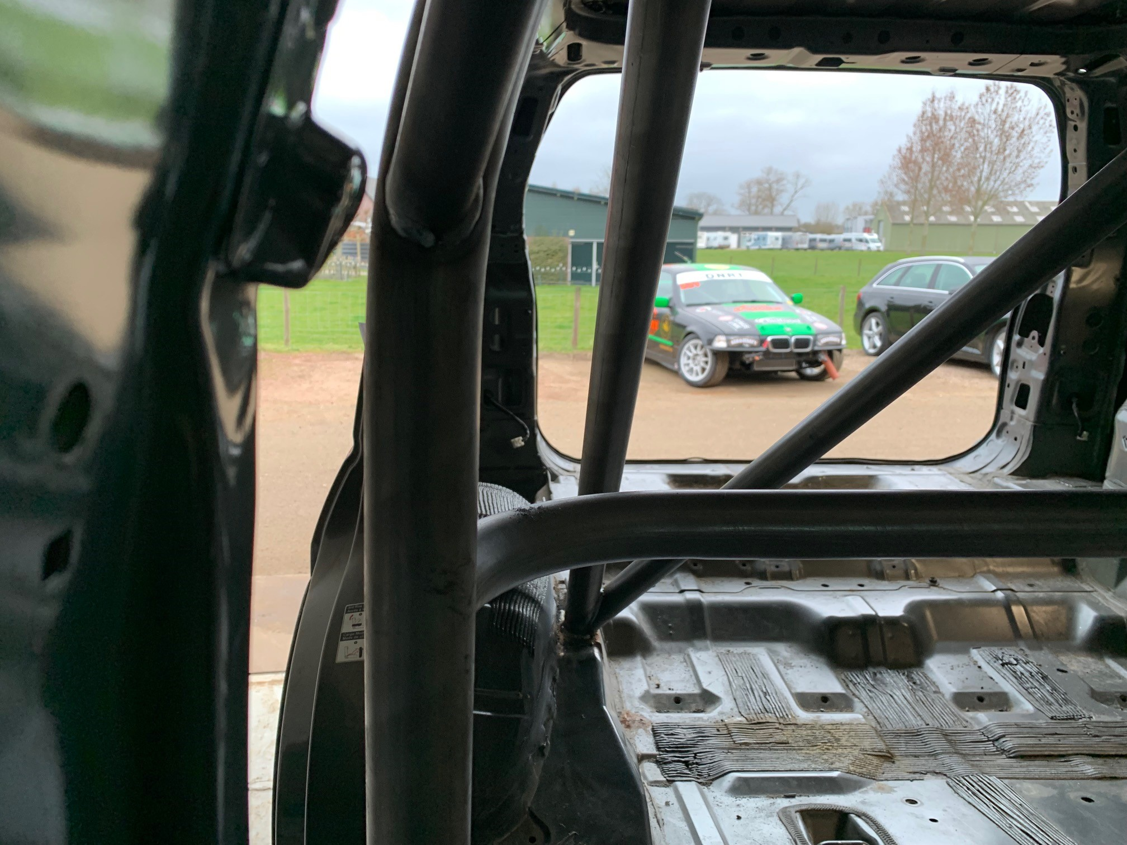

Photo 14  LOCATION OF INDENTIFICATION PLATE |  | PHOTO 16  DETAILS OF INDENTIFICATION PLATE
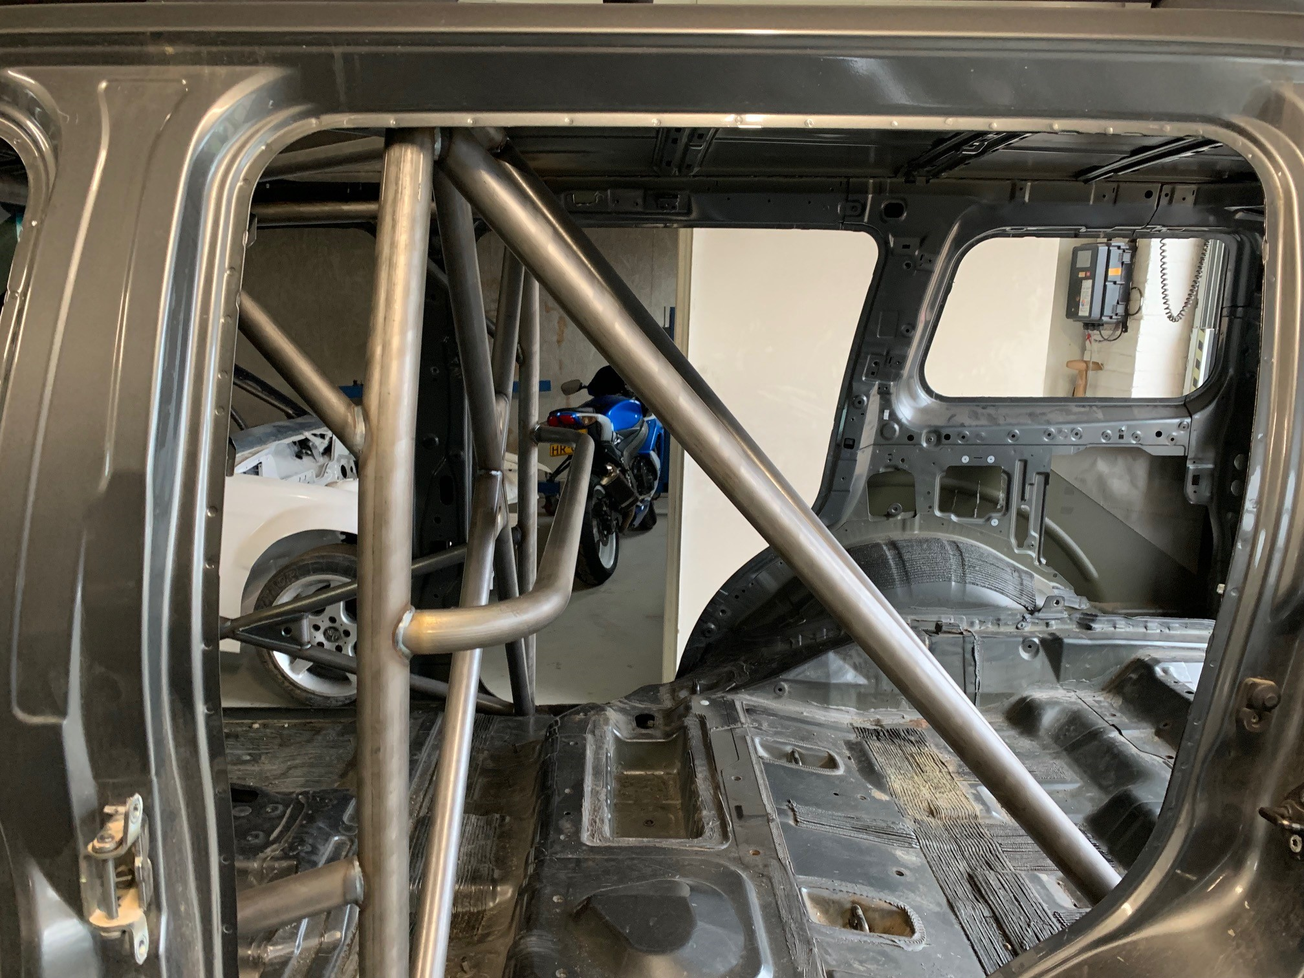

Photo 17  OTHER DETAILS OF CAGE |  | Photo 18  OTHER DETIALS OF CAGE
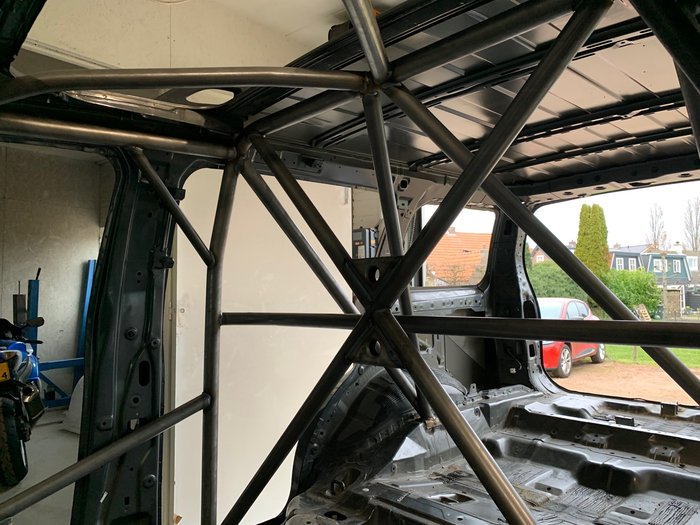 |  | 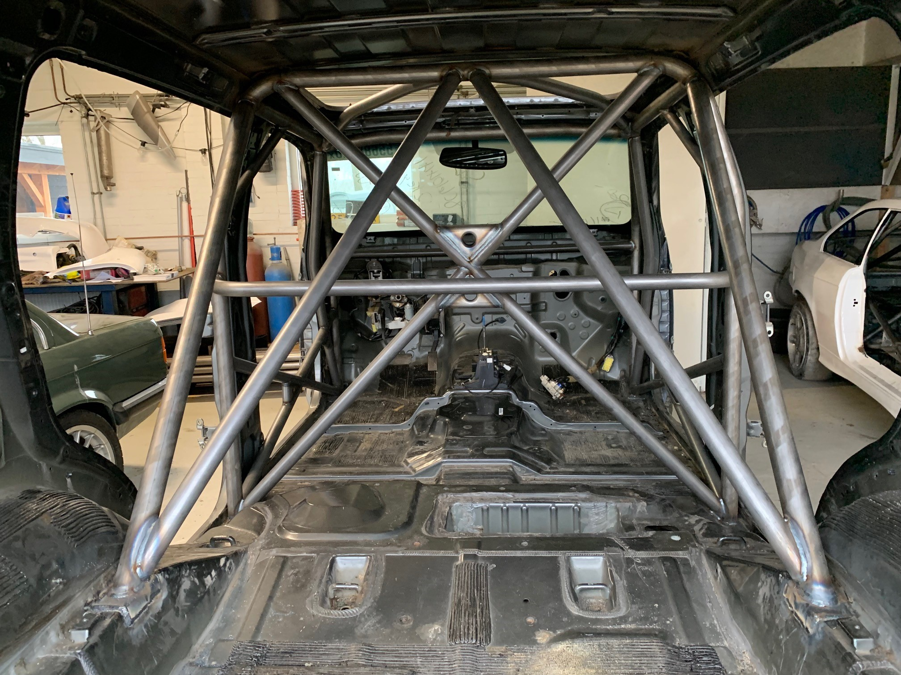

V.I.N. or Chassis Identification Number | 5N1BR18BX8C610441
BABM51040JH28892 | 6090

MANUFACTURER'S DECLARATION AND DETAILS:
I declare that the Safety Cage Structure described on this form and fitted to the vehicle described above:
• was constructed and installed in accordance with the specifications and design shown herein.
• has been manufactured so that all aspects of the Safety Cage design, including configuration and strength requirements and welded and demountable joints and mountings, will be in conformity with the requirements of the FIA Homologation Regulations for Safety Cages.
• has been identified by an engraved plate bearing the name or logo of the manufacturer, ( Biesheuvel Autosport)

Manufacturer’s Name | Biesheuvel Autosport | Insert  Manufacturer Stamp  here
Address | Rijksweg 37
 | 4255 GE Nieuwendijk
 | Netherlands
Phone n° + Email | 0031 183 403400  info@biesheuvel.nl
Signature: | Insert signature here
Name of Signatory#: | N Biesheuvel

MANUFACTURER’S AGENT: (For Safety Cages installed by an Agent)
The following Agent is authorised to act on the manufacturer’s behalf to install this Safety Cage design.

Agent’s Name | GB Metaal Techniek
Address | Bredesteeg 2
 | 4255 GH Nieuwendijk
 | Netherlands
Phone n° + Email | 0031 622607952  info@rolbeugels.nl

Instructions to the installer of the Safety Cage

